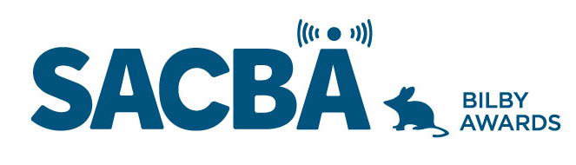
SACBA 2023 BILBY AWARDS ENTRY FORM
Award Category: Can’t Get Out Of The Car

Station:

Date of production/ broadcast/ event:

Names for award *Please note these will be on the certificate if your entry wins

Entry approved by (Station position and signature)

CONDITIONS OF ENTRY:
Only member stations of SACBA can enter the awards
All entries must be received by SACBA by midnight Friday 14 July 2023
All entries must have been produced/occurred between June 2022 & June 2023 One entry per category
Entries must be approved by the station manager or board

HOW CAN YOU HELP THE JUDGES MAKE A DECISION?
Information provided helps the judges so please ensure the entry is described well.
- Fill in the details above & include this page with each entry, to ensure your entry is judged in the right category and that the names are correct on any trophies or certificates
- Answer the questions
- Include photos if you have them
- Make sure all audio is clear and listenable
- audio no more than 5 minutes
- send entries to info@sacba.org.au

Can’t Get Out Of The Car

A segment so riveting you want to keep listening to it, no matter what. Serious, funny, interesting or just plain weird! The segment is clear and easy to understand, is of interest to the station’s community and engages the listener.

- Describe the segment/program

- What makes it so engaging that you have to keep listening

- Was there any listener feedback about it

- Audio required; not more than 5 minutes

