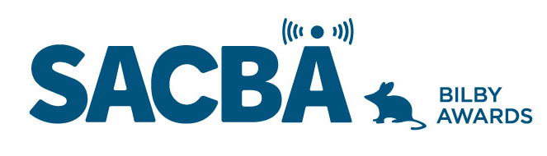
SACBA 2023 BILBY AWARDS ENTRY FORM
Award Category: Community Engagement

Station:

Date of production/ broadcast/ event:

Names for award *Please note these will be on the certificate if your entry wins

Entry approved by (Station position and signature)

CONDITIONS OF ENTRY:
Only member stations of SACBA can enter the awards
All entries must be received by SACBA by midnight Friday 14 July 2023
All entries must have been produced/occurred between June 2022 & June 2023 One entry per category
Entries must be approved by the station manager or board

HOW CAN YOU HELP THE JUDGES MAKE A DECISION?
Information provided helps the judges so please ensure the entry is described well.
- Fill in the details above & include this page with each entry, to ensure your entry is judged in the right category and that the names are correct on any trophies or certificates
- Answer the questions
- Include photos if you have them
- Make sure all audio is clear and listenable
- audio no more than 5 minutes
- send entries to info@sacba.org.au

Community Engagement

Excellence in promoting your station within your community to encourage your community to get involved with your station. Describe how you engage with your community to promote your station and encourage new members, new programs, new volunteers and/or subscribers, new listeners.

- Describe the promotional activity/broadcast

- Which part of your community did this engage with and how many of your volunteers/members were involved

- Describe how you were able to increase community participation in the operations of your station; eg new members, new programs, increase in committee participation, increase in listeners

