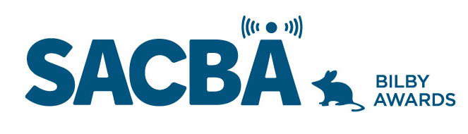
SACBA 2023 BILBY AWARDS ENTRY FORM
Award Category: Excellence in Ethnic/Multicultural programming

Station:

Date of production/ broadcast/ event:

Names for award *Please note these will be on the certificate if your entry wins

Entry approved by (Station position and signature)

CONDITIONS OF ENTRY:
Only member stations of SACBA can enter the awards
All entries must be received by SACBA by midnight Friday 14 July 2023
All entries must have been produced/occurred between June 2022 & June 2023 One entry per category
Entries must be approved by the station manager or board

HOW CAN YOU HELP THE JUDGES MAKE A DECISION?
Information provided helps the judges so please ensure the entry is described well.
- Fill in the details above & include this page with each entry, to ensure your entry is judged in the right category and that the names are correct on any trophies or certificates
- Answer the questions
- Include photos if you have them
- Make sure all audio is clear and listenable
- audio no more than 5 minutes
- send entries to info@sacba.org.au

Excellence in Ethnic & Multicultural Programming

This is for a program/segment or interview that delivers an Ethnic or Multicultural voice to your community

- Describe the program/segment, when it aired and who was involved

- How did it engage with and give a voice to its community

- How did it raise awareness to the wider local community?

- Audio required; not more than 5 minutes

