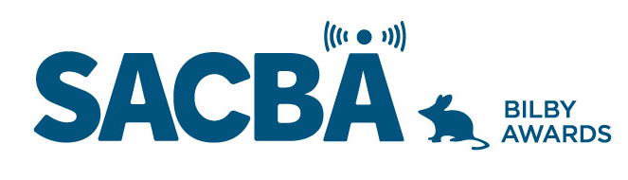
SACBA 2023 BILBY AWARDS ENTRY FORM
Award Category: Local Music

Station:

Date of production/ broadcast/ event:

Names for award *Please note these will be on the certificate if your entry wins

Entry approved by (Station position and signature)

CONDITIONS OF ENTRY:
Only member stations of SACBA can enter the awards
All entries must be received by SACBA by midnight Friday 14 July 2023
All entries must have been produced/occurred between June 2022 & June 2023 One entry per category
Entries must be approved by the station manager or board

HOW CAN YOU HELP THE JUDGES MAKE A DECISION?
Information provided helps the judges so please ensure the entry is described well.
- Fill in the details above & include this page with each entry, to ensure your entry is judged in the right category and that the names are correct on any trophies or certificates
- Answer the questions
- Include photos if you have them
- Make sure all audio is clear and listenable
- audio no more than 5 minutes
- send entries to info@sacba.org.au

Local Music

Every community has music. This is for the program that best supports your local musicians, singers or composers. Single program, series, ongoing program or live event. The program provides a platform for music not generally supported through mainstream media and the presenter/s display a high level of knowledge about local music as well as technical excellence.

- Describe the program, when it aired, who was involved etc

- How does this program support music and musicians who live in your community

- How does the presenter’s knowledge contribute to the program

- Audio required; not more than 5 minutes

