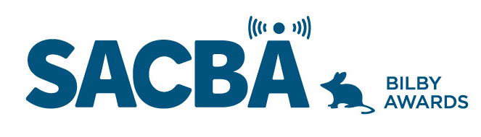
SACBA 2023 BILBY AWARDS ENTRY FORM
Award Category: Best Radio Program

Station:

Date of production/ broadcast/ event:

Names for award *Please note these will be on the certificate if your entry wins

Entry approved by (Station position and signature)

CONDITIONS OF ENTRY:
Only member stations of SACBA can enter the awards
All entries must be received by SACBA by midnight Friday 14 July 2023
All entries must have been produced/occurred between June 2022 & June 2023 One entry per category
Entries must be approved by the station manager or board

HOW CAN YOU HELP THE JUDGES MAKE A DECISION?
Information provided helps the judges so please ensure the entry is described well.
- Fill in the details above & include this page with each entry, to ensure your entry is judged in the right category and that the names are correct on any trophies or certificates
- Answer the questions
- Include photos if you have them
- Make sure all audio is clear and listenable
- audio no more than 5 minutes
- send entries to info@sacba.org.au

Best Radio Program

Music or Spoken word program. This is a program that engages listeners and presents a different perspective on the genre or subject matter. It is technically excellent and is well researched and interesting.

- Describe the program, when it airs, who is involved

- How do(es) the presenter(s) offer new perspectives on the subject matter or genres presented in the program; how does the presenter’s knowledge contribute to the program

- How well does it connect with your community, what listener feedback have you received about the program

- Audio required; not more than 5 minutes

