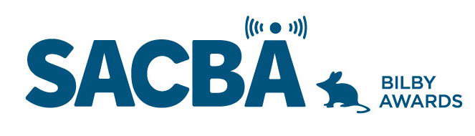
SACBA 2023 BILBY AWARDS ENTRY FORM
Award Category: Volunteer of the Year

Station:

Date of production/ broadcast/ event:

Names for award *Please note these will be on the certificate if your entry wins

Entry approved by (Station position and signature)

CONDITIONS OF ENTRY:
Only member stations of SACBA can enter the awards
All entries must be received by SACBA by midnight Friday 14 July 2023
All entries must have been produced/occurred between June 2022 & June 2023 One entry per category
Entries must be approved by the station manager or board

HOW CAN YOU HELP THE JUDGES MAKE A DECISION?
Information provided helps the judges so please ensure the entry is described well.
- Fill in the details above & include this page with each entry, to ensure your entry is judged in the right category and that the names are correct on any trophies or certificates
- Answer the questions
- Include photos if you have them
- Make sure all audio is clear and listenable
- audio no more than 5 minutes
- send entries to info@sacba.org.au

Volunteer of the Year

A valued volunteer in community broadcasting – someone who gives their time for the benefit of a station or stations and their community. These nominees really do make a difference! This volunteer makes a significant contribution to the station, actively promotes the benefits of the station to your community and has made a positive contribution to the station’s wellbeing.

- How is the nominee involved with your station

- What positive contributions does the nominee make to your station

- What does the nominee do to promote your station within your community

