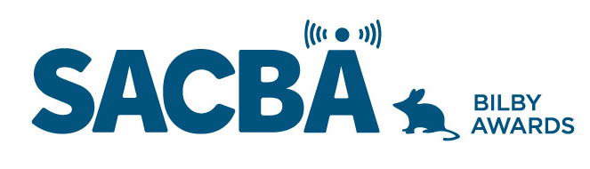
SACBA 2023 BILBY AWARDS ENTRY FORM
Award Category: Youth Contribution

Station:

Date of production/ broadcast/ event:

Names for award *Please note these will be on the certificate if your entry wins

Entry approved by (Station position and signature)

CONDITIONS OF ENTRY:
Only member stations of SACBA can enter the awards
All entries must be received by SACBA by midnight Friday 14 July 2023
All entries must have been produced/occurred between June 2022 & June 2023 One entry per category
Entries must be approved by the station manager or board

HOW CAN YOU HELP THE JUDGES MAKE A DECISION?
Information provided helps the judges so please ensure the entry is described well.
- Fill in the details above & include this page with each entry, to ensure your entry is judged in the right category and that the names are correct on any trophies or certificates
- Answer the questions
- Include photos if you have them
- Make sure all audio is clear and listenable
- audio no more than 5 minutes
- send entries to info@sacba.org.au

Youth Contribution

Contribution to a station or stations by a person under 25 years. In recognition of the value of having young people engaged in community broadcasting. The nominee shows support for other young people who are or could be involved with the station, is involved in many aspects of the station and regularly engages with the station’s community.

- How is the nominee involved with your station

- How does the nominee interact with other people in your station, both young and not so young

- How does the nominee interact with your community and promote a positive image of your station and young people

